INSTRUCTIONS: Completion of Faculty-Led Program Proposal

Before you begin:
Please confirm that you are the individual who should be completing the program proposal. The proposal should be completed by one faculty or staff member per program, designated as the “primary leader.” The primary leader should be a UNL faculty member with academic expertise in the program’s field(s) of study. A qualified UNL lecturer, instructor, Ph.D. candidate, or staff member may be approved to serve as the primary leader at the discretion of the department and college. Note: If a Ph.D. candidate is the primary leader, there should also be a UNL faculty/staff member designated as "program director" to provide academic and administrative oversight.

Be sure you are prepared with the information you will need to complete the proposal.

Steps to Submit a Proposal for Department and College Review

- From our Proposal Process and Deadlines web page, click on the red button of your home college to begin.
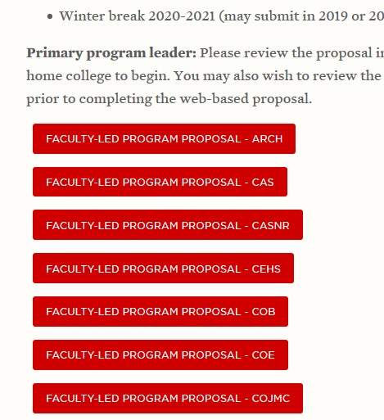

- When you are ready to begin your proposal, click the red “Apply Now” button at the top right of the brochure page.

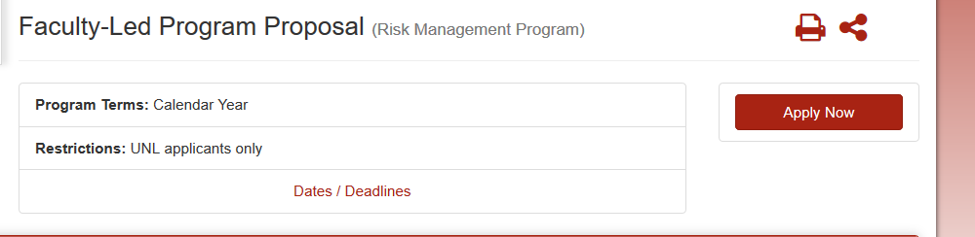

- You will be directed to a page that looks like this:

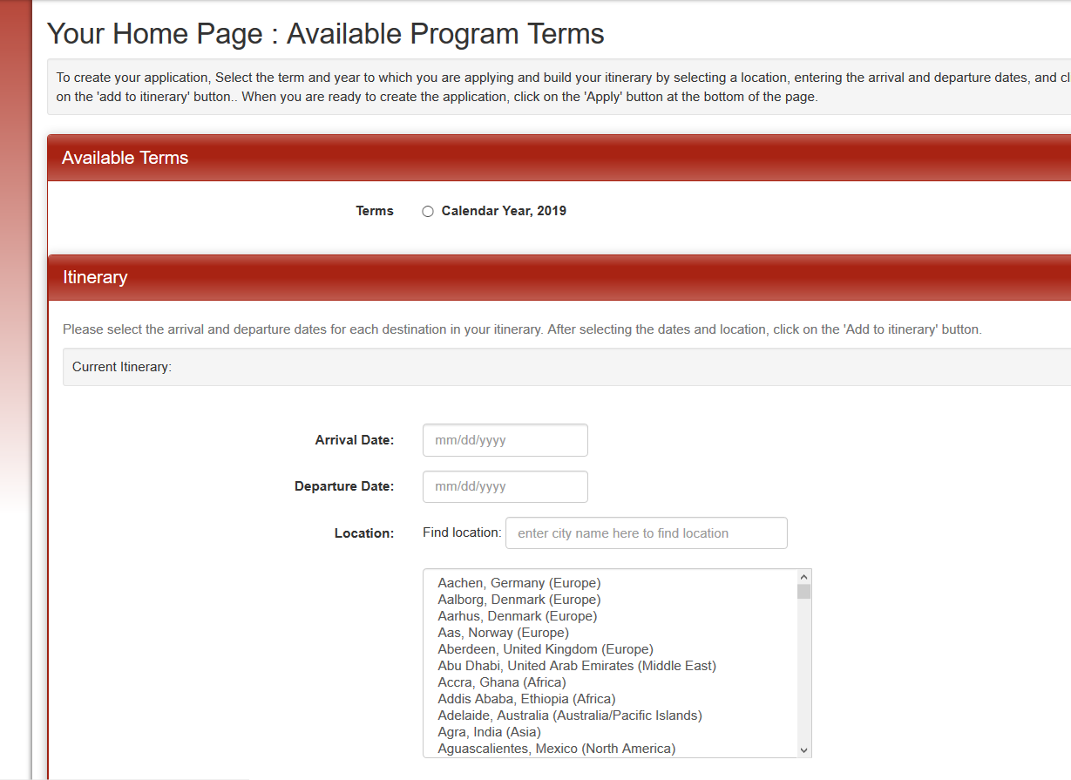

  - Under “Available Terms” at the top of the page, please select the Calendar Year in which the program will take place.
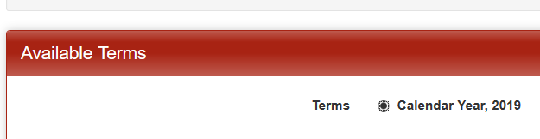

  - Under “Current Itinerary”, enter the approximate dates that your program will occur.
- Arrival Date=Date you will arrive in the host city
- Departure Date=Date you will leave the host city

These dates are not final, and can be changed later. Select the dates and the city* of your program, and push “Add to Itinerary” at the bottom of the page.
*Note: If your program will take place in multiple cities/countries, you will do this for each city your program will travel to.
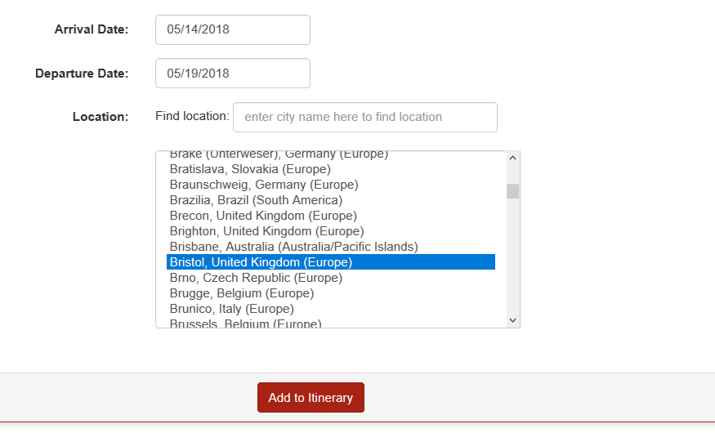

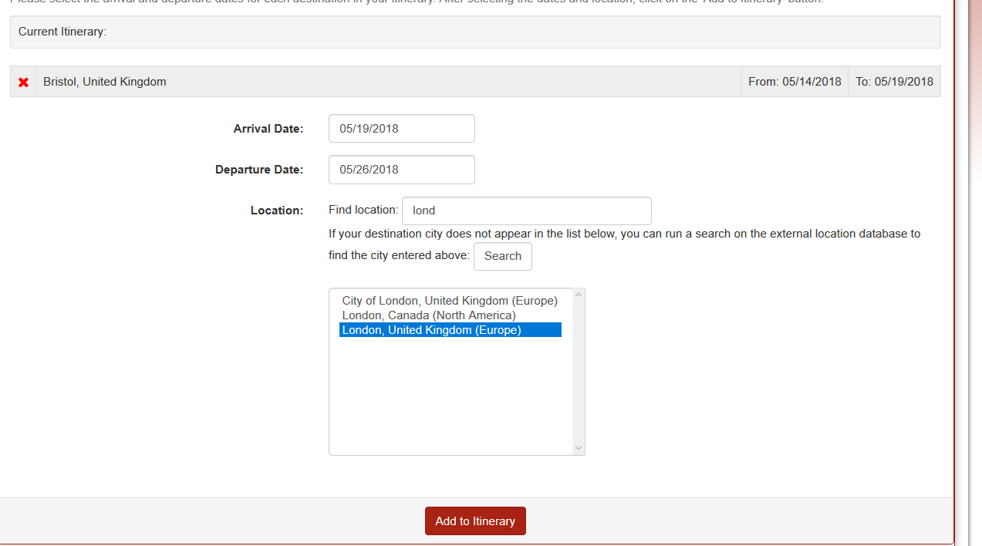

  - When you are finished selecting the dates and locations of your itinerary, push “Apply” at the bottom of the page.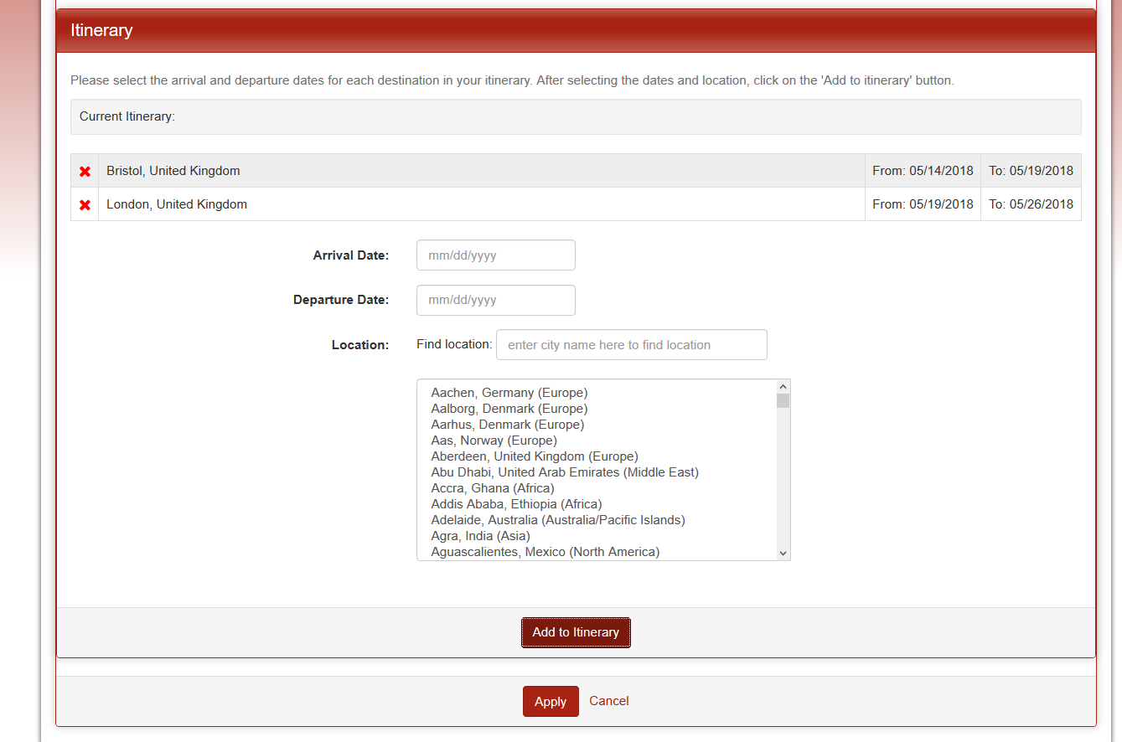

- Click on the gear icon in the top left corner of the black bar, to the right of your name. Select “Edit profile.” Add your date of birth. (This will allow the system to know that you are older than 18 and thus do not require a signature from a parent/guardian).

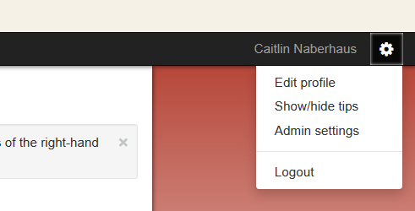
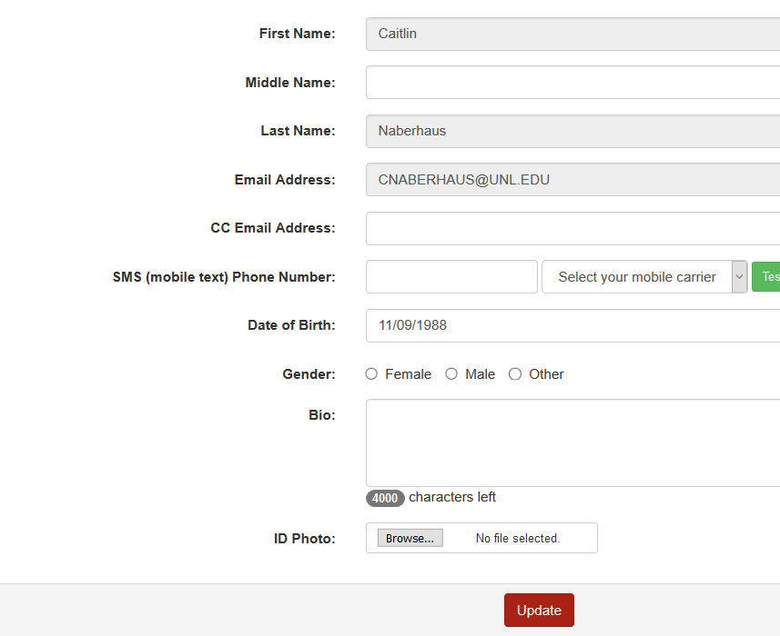

- To return to your Program Application Page, click the house icon on the left, select “Applicant”, and then click on the red Faculty-Led Program Proposal application link.

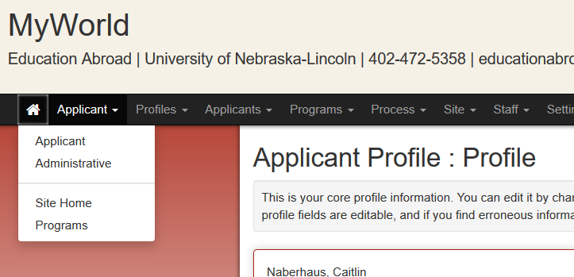
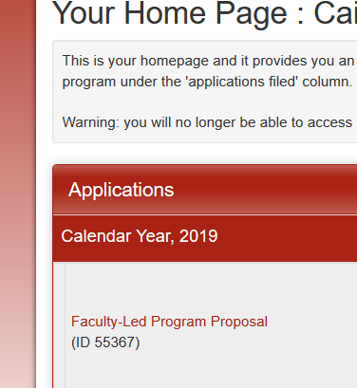

- Scroll down past “Application Instructions”, and read and e-sign the two Signature Documents entitled “Faculty-Led Program Proposal Process & Deadlines” and “Leader Time Commitment”.

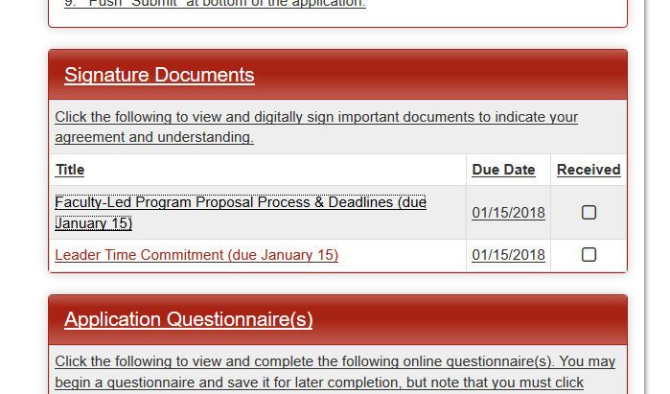
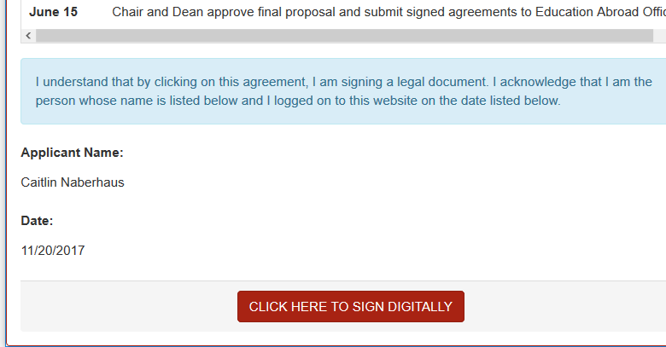

- Complete the Application Questionnaires 1-7.

- Once complete, push “Submit” at the bottom of the questionnaire.
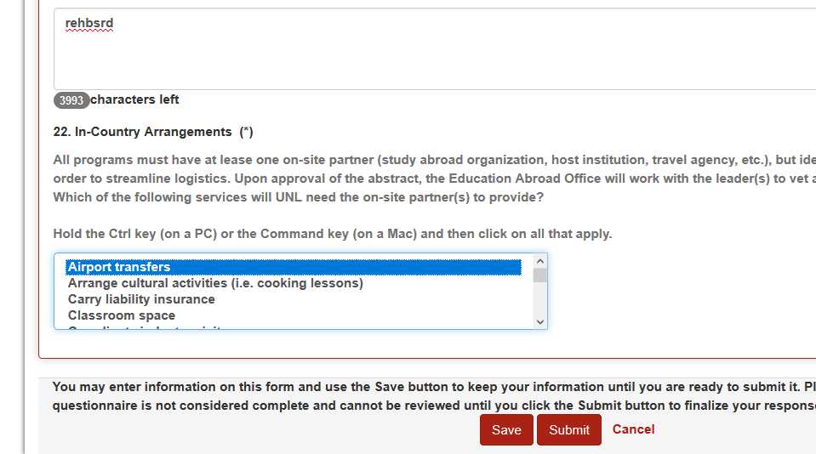

Congratulations, you’re finished submitting your draft proposal! Please log-out of MyWorld.

Making changes to your draft proposal

After logging in to MyWorld:
1) Click the house icon at the top left of your home page.
2) Select “Applicant” from the drop down menu.
3) Choose “Faculty-Led Program Proposal” under the heading of “Applications.”
4) Scroll down to the heading for “Application Questionnaire(s)” where you will find all seven questionnaires listed.
5) Find the questionnaire you wish to edit and click on the pencil icon on the right hand side.
6) Make any changes you wish and then click the questionnaire’s “Submit” button once again.

Education Abroad Office
Love South 110
educationabroad@unl.edu
402-472-5358
educationabroad.unl.edu

